Chapter 7
Mycorrhizae Fungi

One of the oldest examples of a mutualistic symbiosis where both partners benefit is the example of land plants and mycorrhizal fungi. Researchers hypothesize that these fungi, which reside on and/or in the roots of plants and help the plant acquire water and nutrients, are what enabled plants to move out of water and onto the land (Bonfante and Genre 2008). The fact that this relationship has been developing for hundreds of millions of years is reflected in the fact that the majority of land plants form some sort of intimate relationship with mycorrhizal fungi (Chenchouni et al. 2020). Some plants, sometimes even individual roots, can form associations with more than one mycorrhizal fungus (Blaschke 1991).
Mycorrhiza literally means ‘fungus-root’ and is the ideal name for this example of coevolution. Clearly, since this relationship has been developing and evolving for millions of years, both partners must be pretty specialized in their roles. But what is each organism getting out of the relationship?
Fungi are heterotrophs. They must acquire carbon from their environment. Mycorrhizae do so by siphoning off carbon fixed from atmospheric CO2 by their plant hosts. Plants are able to synthesize sugar from sunlight, CO2 and water. Plants produce more sugar than they use for growth of their own bodies. Rather plants shuttle a majority of its sugars down to its roots where it is released around the root zone in the rhizosphere (Aulkah et al. 2001). One function of these root exudates is to attract beneficial microorganisms to this area that assist the plant in various ways (Herz et al. 2018).
Of the microbes attracted to this sugary extracellular matrix, mycorrhizal fungi are included. Spores of some mycorrhizal fungi even depend on the presence of this root exudate to germinate (Vierheilig et al 2003). Once the spores detect the presence of certain compounds, they begin to swell and a hypha known as a germ tube will emerge from the germinating spore. The hyphae will continue to grow towards the root and, depending on the particular fungus, may penetrate the plant cell wall (as in the case of endomycorrhizae infecting Cannabis) or may form a sheath surrounding the plant root (ectomycorrhizae) (Fig. 8.1). One common example of an ectomycorrhizal fungus is the fly agaric or Amanita muscaria.
Once the plant and fungus have developed this connection, the fungus begins acquiring water and nutrients, in particular difficult to acquire nutrients such as phosphorus, from its surrounding environment and shuttling these resources back to the plant. The fungal hyphae are much thinner than a plant root and are very highly branched. By having a fungus attached to the plant root, extending out into the soil substrate, the plant greatly increases its root surface area and its ability to access areas that the plant would not be able to penetrate without the help of fungi.
Mycorrhizal fungi also release organic acids, enzymes, and siderophores into the environment to break down complex molecules into simpler compounds and chelate them into forms fungi and plants may utilize. Thus, the fungi are able to access and acquire mineral nutrients from environments and at rates that plants would be unable to achieve on their own. Fungi then share these minerals with plants in exchange for the sugars that plants produce via photosynthesis. The exchange of nutrients and carbohydrates is what these relationships are built upon. There may also be complex transfer of nutrients and even signaling molecules through networks of plants interconnected through the same mycorrhizal mycelium.
In nature, there are many different types of mycorrhizal relationships that we can observe. There are three main types of mycorrhizal interactions, with many sub-classes being discovered every year. Some people now consider there to be as many as six different types of mycorrhizal associations (Brundrett 2009). The two categories we will discuss are, endomycorrhizae and ectomycorrhizae. Because endomycorrhizae are the only group known to form direct partnerships with Cannabis, we will focus on this group.

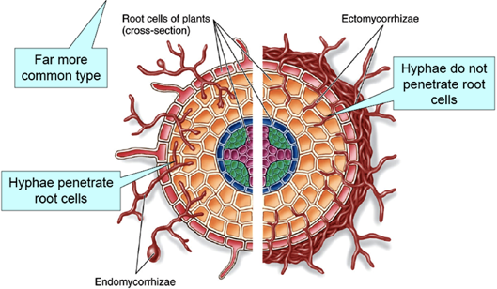
Figure 7.1. Endomycorrhizae (left) vs Ectomycorrhizae (right). The major physiological differences being the mantle formed around the root with ectomycorrhizae and the fact that endomycorrhizae penetrate the root cell, whereas ectomycorrhizae remain in the intercellular space. Only endomycorrhizal fungi form mycorrhizae with Cannabis roots. https://www.plantscience4u.com/2013/03/ectomycorrhizae-and-endomycorrhizae.html#.W14dsBOPLBI

Table 1. Common species of Endomycorrhizae vs Ectomycorrhizae
Endomycorrhizae | Ectomycorrhizae
Funneliformis  Glomus  Rhizophagus  Gigaspora | Tuber (Truffle)  Amanita  Laccaria  Boletus  Morel
Plant associates: Cannabis, most vegetable and herbaceous plants, many grasses | Plant associates: Hardwood and softwood trees, many woody plants

Mycorrhizae Taxonomy
As with every other group of fungi, the taxonomy of mycorrhizal fungi is in a state of flux. Constantly species are being renamed or reclassified as we learn more about the fungal kingdom and as our identification techniques advance and get more sophisticated. However, there are some broad guidelines that are generally followed.
Endomycorrhizae recently used to have their own phylum called ‘Glomeromycota.’ More recent phylogenetic analysis places them within the Mucormycota as the subphylum Glomeromycotina. Fungi in Glomeromycotina lack septa, thus are coenocytic, and are obligate symbionts of members of the Kingdom Plantae. Cultivation of these fungi can be difficult because they cannot be cultured in the lab (In vitro) without a host. Rather, they must be cultured with an appropriate plant symbiont. The spores are produced directly from the mycorrhizae hyphae and are dispersed within the soil. Collection of spores for inocula production occurs after the plants grow and die. From a practical standpoint it is much easier to collect spores from a mushroom than from an endomycorrhizal fungus.
Ectomycorrhizal (ECM) fungi are typically within the phyla Basidiomycota and Ascomycota. Reproduction is usually via sexual spores and many ECM fungi produce recognizable mushrooms or hypogeous (underground) fruiting bodies, such as truffles. Most deciduous and coniferous trees form associations with ECM fungi. Ectomycorrhizal fungi are found in all types of forest, though they are often particularly diverse and abundant in old-growth forest where the soil has never been disrupted. The other major forms of mycorrhizae are also from these two dikarya phyla, including Orchid mycorrhizae (Basidio-), Ericoid mycorrhizae (Asco-), and Monotropoid (Baidio-). There is no evidence that any of these higher fungi can form mycorrhizal infections with Cannabis plants.
Table X Different mycorrhizal groupings and associated characteristics.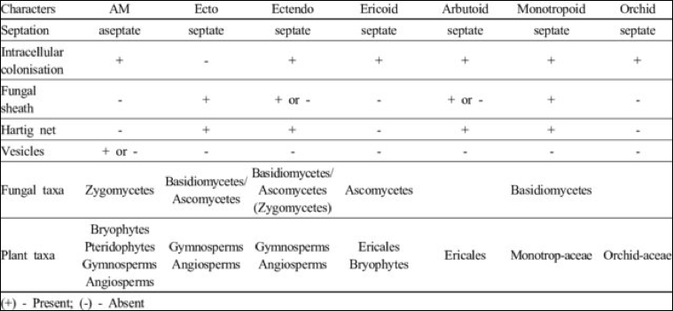

Endomycorrhizae
Endomycorrhizae are obligate mutualists that form associations with many vascular plants. Endomycorrhizae are very common in nature and are often considered ‘generalists’ since most are not host specific and may infect many different plant species. It is estimated that over 80% of all species of land plants form associations with this grouping of fungus (Schwarzott et al., 2001). Endomycorrhizae typically associate with more short-lived, annual crops and as such are particularly important for agriculture. Many of the crops we cultivate (corn, wheat, and most vegetables) form associations with species of endomycorrhizae.
One reason why classification of these fungi has remained unresolved is that they can not be cultured without a host and thus are difficult to study in vitro. Until recently, it was believed that all endomycorrhizal fungi belong to the subphylum Glomeromycotina, formerly phylum Glomeromycota (Bruns et al 2017). Within the Glomeromycotina, there are 3 classes, 5 orders, 14 families, with 29 genera and approximately 230 individual species (Oehl et al. 2010). Glomeromycotina are also referred to as arbuscular mycorrhizal fungi ‘AMF’ or vesicular arbuscular mycorrhizal fungi ‘VAM.’ These names are derived from the tree-like structures of branching hyphae (arbuscules) they form between the cell wall and cell membrane (the periplasm) of the root cells of plants they infect.
There is emerging evidence that the sister subphylum to Glomeromycotina, Mycoromycotina, may also form mycorrhizal relationships with a wide variety of plants (Bonfante and Venice 2020, Howard et al 2022). This grouping may also form arbiscules that have historically been misidentified as Glomeromycotina. The hyphae of the Mucoromycotina endophytes is distinctive, however, with one of its defining features being its smaller hyphae diameter (<2um). This has led to the group being referred to as the Mucoromycotina Fine Root Endophytes (MFRE) (Table 2). There is evidence that the MFRE and AMF form complementary associations with the same plants, providing different nutritional exchanges with the plant. Nitrogen is the major nutrient MFRE provide to their host plants whereas phosphorus is often the most significant nutrient AMF scavenge, both in exchange for carbon nutrition from (Field et al 2019).

All Glomeromycotina (AMF) form arbuscular mycorrhizal associations and share certain traits and characteristics. For instance, AMF all have coenocytic hyphae (aseptate), require a host organism to complete their life cycle, and reproduce via spores. Mucoromycotina Fine Root Endophytes (MFRE) similarly have coenocytic hyphae and reproduce via spores, however MFRE are not obligate symbionts; MFRE may also be facultatively saprophytic -capable of survival, growth, and reproduction without a living plant host (Field et al. 2015). The saprophytic capabilities of MFRE may offer avenues to work with this grouping in a manner impossible with the obligate symbionts within the AMF.

Table 2. Hierarchical classification of Arbuscular Mycorrhizal Fungi (Walker et al 2018)
Kingdom | Fungi
Phylum | Mucoromycota | Mucoromycota
Subphylum | Glomeromycotina | Mucoromycotina
Class | Archaeosporomycetes, Glomeromycetes, and Paraglomeromycetes | Mucoromycetes
Order | Archaeosporales, Diversisporales, Gigasporales, Glomerales and Paraglomerales | Endogonales, Mucorales  (Incertae sedis)
Family | Glomeraceae, Gigasporaceae, etc. | Endogonaceae  (Incertae sedis)
Genus | Glomus, Gigaspora, Funneliformis, Rhizophagus, ect. | Planticonsortium
Species | Funneliformis mosseae, Rhizophagus intraradices, ect. | Planticonsortium tenue (Synonym, Glomus tenue)

The mechanism for a spore being able to find a root susceptible to infection is a complex question that scientists have not yet fully understood. What scientists do know is that both of these organisms can grow toward each other, even though they are unable to physically move (another challenge of being a sessile organism). Several environmental parameters are thought to influence spore germination: pH, temperature, microbial community, nutrient availability (Giovannetti et al 2010).
Since plants are sessile and must remain in one location for the entirety of their life, they instead attract and cultivate a community of microorganisms which may benefit their own fitness. Plants do this by excreting chemicals (exudates), mostly carbohydrates and pheromones, from its roots. This microenvironment proximate to and permitted by the roots of a plant is known as the rhizosphere.
These root exudates are complex, consisting of many different types of compounds to select for a diverse microbial community. Research has shown that a significant amount of the sugars that a plant produces from photosynthesis are actually shuttled to the roots where they are secreted to attract these organisms (Canarini et al. 2019). So by releasing sugars, which are mainly carbon and hydrogen in composition, and other pheromone-like compounds into the rhizosphere directly surrounding the root, the plant is able to signal compatible organisms, like endomycorrhizal fungi, to grow towards the root. Eventually, the hyphae from the fungus will reach the root, where the hyphae will grow and penetrate the cell wall and enter the plant root.
As the fungus nears the epidermis of the root, the growing hyphae begins to secrete mucilage and other sticky compounds with the purpose of adhering to the plant (Balestrini and Bonfante 2014). The fungus senses it is near the plant root due to the presence of certain exudates (particularly lactones) produced by the host and the hyphal tip will begin to swell and develop a specialized structure known as an appressorium or hyphopodium (Genre et al. 2005). This ephemeral structure only serves to help form the association and then is broken down after penetration is complete.
Typically entrance will be achieved through a single-celled root hair and never through the root meristem (Bonfante and Genre 2008). Once entering the plant cell wall, the hypha travels intracellularly through the apoplastic pathway until it reaches the cortical tissue (Genre et al. 2005). Upon arrival at the root cortex, endomycorrhizal fungi begin to develop highly specialized abuscules to begin the communication and exchange of resources between the two organisms (Fig. 2). The hypha that is now invaginated in the plant cell is surrounded by a perifungal interface, which is a cell wall-like barrier of plant origin that is surrounded by the plasma membrane (Bonfante and Genre, 2008). Arbuscules and /or coils are where the fungus and plant exchange nutrients because of the great surface area of contact that the two organisms share, allowing maximum interface between the fungus and the plant cell.
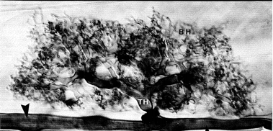
Figure 7.2. A highly branched arbuscule of AMF growing within the cell wall. The hyphae of AMF do not penetrate the cell membrane but instead invaginate the cell and are surrounded by a perifungal interface. Taken from Brundrett et al 1984.

Another structure that AMF can produce once inside the root are vesicles. In the past AMF were referred to as Vesicular Arbuscular Mycorrhizae (VAM or VA) and you may still see them referenced as such, especially in older textbooks. However, since not all Glomeromycotina fungi produce vesicles, the name was eventually abandoned for the more commonly accepted ‘Arbuscular Mycorrhizal Fungi.’
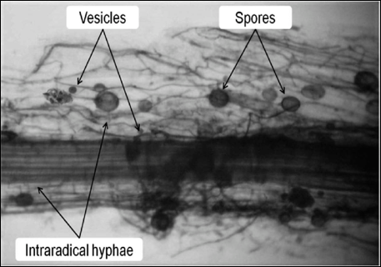
Fig. 7.3 Plant root infected with endomycorrhizae that are producing vesicles, spores, and hyphae penetrating the root and growing in between cortical cells.

If an AMF fungus does produce vesicles, these structures will be produced in the roots, either in between or within the cortical root cells. Since the vesicles consist mainly of lipids and other nutrient dense compounds it is hypothesized that fungi use these as storage structures to endure harsh conditions.The remaining mycelium of the fungus extends back to the soil matrix where it encounters mineral soil and organic compounds and excretes extracellular acids to solubilize nutrients. It absorbs nutrients into its hyphae, which the fungus may pass onto its host plant(s).
Certain compounds released by AMF, such as glomalin, deposit carbon into the soil, which can improve the soil organic matter while at the same time sequestering carbon from the atmosphere and stabilizing the soil structure (Zhu and Miller 2008). This can have dramatic effects on the plant community and the overall resilience of the ecosystem.
In addition to helping Cannabis plants scavenge nutrients and moisture, endomycorrhizal fungi have also been shown to help plants ward off unwanted soil fungi that are pathogenic. Examples of pathogenic soil fungi include Fusarium and Verticillium species (Benhamou et al. 1994, Liu 1995). Not only do the mycorrhizal fungi physiologically protect the root, but also compete with pathogens for photosynthates and resources, limiting the effect the invader has on plant growth (Singh and Giri 2017). Other suggested mechanisms of protection offered by endomycorrhizae could be due to increased nutrient uptake and growth of infected plants, altered rhizosphere populations, changes to root structures and by inducing plant defense pathways (Singh and Giri 2017).
Endomycorrhizal fungi have at least one more potential benefit that they may be able to offer Cannabis growers: the ability to translocate heavy metals. The environmental remediation sector of Cannabis growers may benefit from the research that shows when Cannabis was inoculated with Funneliformis mosseae and planted in soil contaminated with heavy metals, heavy metals were translocated to the shoots and above-ground biomass (Citterio et al. 2005). Plants that were not inoculated had heavy metal accumulation in the roots. Therefore, inoculating roots with certain AMF in Cannabis phytoremediation projects would help remove more metals from the soil. Craft flower growers, on the other hand, may need to exercise caution when incorporating AMF if they are growing in soils with heavy metal contamination.
Mycorrhizal fungi are connected to the hyphal system or mycorrhizal network (MN) of other plants, of the same and different species. Through this network, Mycorrhizal fungi can help plants send distress signals to other plants nearby, informing neighboring plants of potential danger (Gorzelak et al. 2015). Thus, the mycorrhizal networks found in the soil really connect many, often unrelated plants in any particular ecosystem. These connections allow plants to communicate, and share (or steal) resources from their neighbors. This may be one benefit to growers who use raised beds, where multiple plants are grown in the same container and thus the roots and fungal partners of neighboring plants can interact (Higgins and Hussey, 2019).
These mycorrhizal networks that connect plants can be fragile and relatively close to the soil surface. Therefore, by tilling up soil prior to planting, you may be disturbing the mycorrhizal communities. Following a disturbance, there are likely to be fungal spores that remain in your field, however, it will take more time for the fungus to find the plant root and form an association (Kabir 2005). This is one of the reasons considered by some farmers who choose to switch to no-till techniques.

Mycorrhizae in the garden
There are many commercially available mycorrhizae products on the market today. Go into any nursery or super store and there will likely be numerous products that contain various mycorrhizal species. When shopping for the Cannabis plant, it is important to be selecting products that contain endomycorrhizal fungi. The timing of application is also important to increase the effectiveness of the various products.
Many of the products are sold in a dry powder or granular form. We like to use these products whenever transplanting plants. Take some of the dry powder (we like to put the powder in an old seasoning bottle for easy application) and pour directly onto the exposed roots. We will then rub the powder along the roots to ensure even application and that spores will come in direct contact with the roots. When treating large quantities of plants, you may dip and agitate the rootball in a bowl of powdered inocula. These dry products contain the spores of mycorrhizae fungi and/or “propagules.” The propagules are typically root fragments that have previously been colonized by a mycorrhizal fungus which will eventually grow out and colonize the new root zone.
Other products are sold as a wettable powder or as a liquid solution that is meant to be watered in as a soil drench, thus getting the mycorrhizal spores/propagules close to the rhizosphere, or used as a liquid root dip. The liquid products can also be put into a spray bottle and sprayed directly onto roots at time of transplant. Do not spray on any part of the plant besides the roots. The products contain mycorrhizal propagules that will begin to grow and search for roots once watered into the medium. As such, these products can be used to inoculate plants at any time in the growing phase. However, in order to gain the most benefits from mycorrhizae, it is important to inoculate roots when they are young, developing lots of root hairs and branching, and before the plant’s rhizosphere becomes dominated by non-mycorrhizal soil microbes (including potential pathogens).
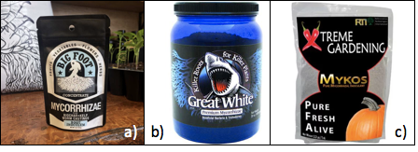
Figure 7.4. Commonly available mycorrhizae products marketed towards the Cannabis industry.

Important Notes:
- In high phosphorus environments, mycorrhizal associations may not develop and in some instances, the fungus may actually negatively impact the growth of the plant (Ortas 2003). Cannabis growers must be conscious of this when adding bloom boosters or high phosphorus fertilizers if also attempting to utilize mycorrhizae.
- Mycorrhizal fungi may contribute to heavy metal accumulation in the aerial parts of Cannabis if the soil is contaminated.
- Mycorrhizal products may harbor viruses and bacteria. There is currently no viral indexing of mycorrhizal products sold on the market.

By incorporating mycorrhizae into your indoor Cannabis garden, you can increase the tolerance of your plants to abiotic stresses, such as heat and drought, and biotic stressors, including molds and insects (Trouvelot et al. 2015). Plants with mycorrhizal partners are also better at scavenging nutrients and minerals, often leading to larger, more robust, healthier plants (Fig. 7.4).
In an outdoor Cannabis garden it becomes even more important to inoculate plants with mycorrhizae. Depending on the location and past uses of the farm, there may be spores in the soil, yet inoculating plants can improve the infection rate of plants. Outdoor soils typically can have a more diverse microbial community and are often subjected to more stress. Outdoor soil consisting primarily of sand, silt, and clay, also behaves differently (chemically, physically, and biologically) than indoor potting media which is typically peat or coco coir based. Depending on the soil type, many ionic nutrients may be bound to soil particles and mycorrhizae fungi are particularly good at freeing up these elements and making them plant available.
There are very few studies that have documented the benefits of using mycorrhizae in hydroponic systems but there is research being conducted in this area (Ojala and Jarrell 1980, Aini et al. 2019, Caser et al. 2019, Nurbaity et al 2019). Many have reported anecdotal evidence that incorporating these fungi in these systems has benefits, but solid evidence and hard data is somewhat lacking in regards to Cannabis production in hydroponic systems.

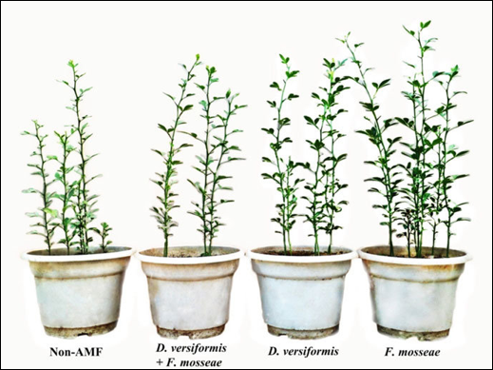
Figure 7.5. Trifoliate orange seedlings inoculated with 2 different types of AMF (D. versiformis and f. mossae).

Ectomycorrhizae
The second most common mycorrhizal association is ectomycorrhizae (ECM). Although not forming relationships with Cannabis plants, ECM are commonly associated with most tree and shrub species. Often these fungi form large mushrooms, some of which are edible and quite delicious, whereas others can make you extremely sick or hallucinate. The stereotypical ‘Alice in Wonderland’ mushroom, Amanita muscaria, is an example of an ectomycorrhizal mushroom. Other examples include morels, truffles, and bolete mushrooms (Fig. 5).
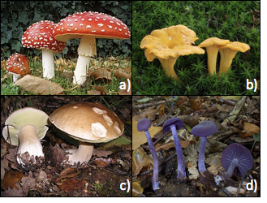
Figure 7.6. Common ectomycorrhizal fungi. a) Aminita muscaria; hallucinogenic, b) Cantherellus cibarius; choice edible, c) Boletus edulis; choice edible, d) Laccaria amethystina; edible.

Whereas endomycorrhizal funga all belong to the same phylum, ECM are spread among the phyla Basidiomycota and Ascomycota and, less frequently, Mucoromycotoina. Therefore, this is not a monophyletic lineage, indicating mycorrhizal, fungi-plant interactions have evolved independently multiple times. Communities of ectomycorrhizae are often found in old growth forests where they form relationships with many, if not all, of the tree species.
Some species of ECM can be quite particular about the host that they form a relationship with, while others act as generalists and will form relationships with many different partners, often at the same time (Horton and Bruns 1998). Not only can one individual fungus associate with multiple plant species, but a single plant root can have many fungal species growing on different sections of the root. These relationships, and the resulting connectivity of life in an encosystem, can get quite complex.
Although coming from a diverse genetic background, most ECM fungi infect plants in a similar fashion. Ectomycorrhizal fungi will typically develop a sheath of fungus, also called the fungal mantle, all around the outside of the plant root (ecto- means outer). Ectomycorrhizae grow and envelop the plant root, with some hyphal filaments extending out into the soil and some hyphae that enter the root, but never penetrate the cell wall of the plant, a key difference between AMF/MFRE and ECM (Fig. 8.6). Ectomycorrhizal fungi will form a network of hyphae in the intercellular space between the plant cells of the root cortex (the tissue between the epidermis and endodermis of a root). This branched area of hyphae is known as the Hartig Net, and serves to maximize the interface between the plant and the fungus. It is similar in function to arbuscules in endomycorrhizae.
Another key difference between AMF/MFRE and ECM is found in the mycelium; ECM fungi will typically have septate hyphae. Depending on the particular fungus and whether it belongs to Basidiomycota or Ascomycota, the mycelium will have either dolipore septa with clamp connections or simple porate septa, respectively.

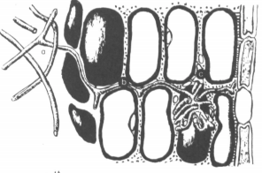
Figure 7.7. ECM infecting the root of a tree host. The hyphae travels intracellularly within the root, as far as the endodermis. The hyphae extensively coils around certain plant cells, forming the hartig net, for maximum exchange capabilities. Taken from Nylund and Unestam 1982.

Similar to other types of mycorrhizal relationships, both partners benefit from this relationship. In general, the plants share carbohydrates from photosynthesis with the fungus, where the fungus supplies the plant with additional water and nutrients. There is also some evidence the ECM relationship may also help protect trees from potential pathogens and can even signal to other trees in the area through the mycorrhizal network (Gorzelak et al. 2015).
Since ectomycorrhizae are more often seen infecting perennial woody plants and trees; both hardwood and softwood, we do not really encounter these fungi much in the vegetable or Cannabis garden. Despite this some companies are currently selling products designed for use with Cannabis that contain ectomycorrhizal spores, usually of species that associate with woody trees. In our opinion, this is a prime example of ‘label dressing’, where companies try to make products look more attractive by increasing the ingredient list, even though the ingredients likely serve no purpose. These companies are preying on an uneducated customer base. Ectomycorrhizal fungi play important roles in nutrient cycling and transfer in forest ecosystems, and may confer some of these benefits while acting as saprophytes in a Cannabis or vegetable garden. But they will never form mycorrhizal associations with Cannabis roots.

A Note of Caution
Although the plant-mycorrhizae relationship can be beneficial for both partners, recent research has shown that there could be some potentially damaging consequences of mycorrhizal infection. Miozzi et al. reviewed the current research in 2019 and revealed that in certain situations plants that have mycorrhizal partners may have increased susceptibility to pathogenic viruses, a term they coin “mycorrhiza-induced susceptibility” (MIS). Scientists are still working to understand this phenomenon better and its potential implications. There may even be direct biological risk to endophyte introductions if they carry pathogens themselves (see Chapter 11 on the emerging threat of fungi as hosts and vectors of plant viruses).
Another study by Garrido et al. showed that increasing the rate of inoculums with Glomus species actually decreased the plants ability to defend itself to herbivory (Garrido et al. 2010). Again the mechanisms here are not yet fully understood but the point here is that under certain circumstances mycorrhizal inoculation may not be the best use of fertilizer dollars. The key is to experiment, observe, and measure the plant response when debating adding any new product into your grow or farm.

Rhizophagy Cycle
Another example of mutualistic symbiosis with microbes and plant roots is termed the Rhizophagy cycle. Literally, rhizophagy means ‘root-eating’ which is appropriate because the plant roots seem to be consuming the free-living microbe, extracting nutrients and then expelling said organism back outside of the root. In this way, our concept of plants as autotrophic organisms is challenged by a heterotrophic process of nutrient acquisition (Paungfoo-Lonhienne et al. 2010).
Rhizophagy is a cyclic process where certain rhizosphere bacteria and yeasts are assimilated into root cells where their cell wall of the microbe disappear due to reactive oxygen species produced by the plants. Once the cell wall is degraded, the plasma membrane of the microorganism still persists but nutrients begin to ‘leak’ from the bacteria/yeast and the plant is then able to assimilate these new found elements (White et al. 2018). Once the electrolytes are stripped from the single-celled organisms, the wall-less microbes migrate towards root hair cells. This causes elongation in the root hairs, allowing the microorganisms a place to exit the plant root, where they will re enter the soil solution and begin to reform their cell wall and collect resources to continue growing until they are again assimilated by plant roots.
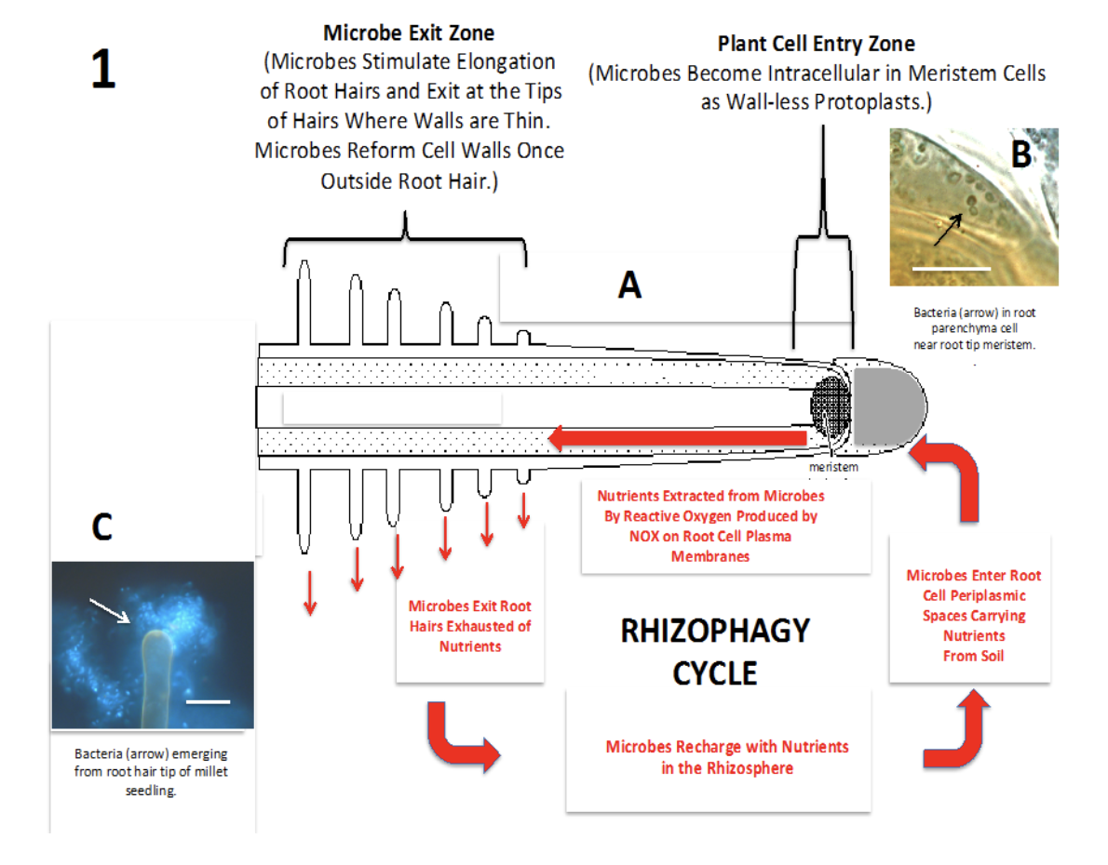
A
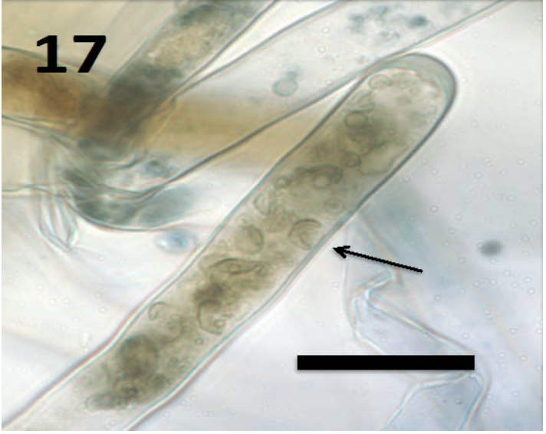
B
Fig 7.8 A) Diagram of rhizophagy cycle in plant root. B) 100x magnification yeast cell inside root hair White et al. 2018
It is unknown how much of a plant's nutrient needs can be met through the rhizophagy cycle but knowledge of this mechanism fundamentally changes the way we must view plants and plant nutrition. Researchers are uncertain if it is only specific species of bacteria and fungi that can participate in the rhizophagy cycle but for now it seems as though most microbes found to colonize roots are likely able to engage in this interaction (White et al. 2018).

